**Devam Desai**

**IIT2022035**

**DBMS ASSIGNMENT 2**

**Note: All work was done on the original TPCH dataset.**

**Q1. Q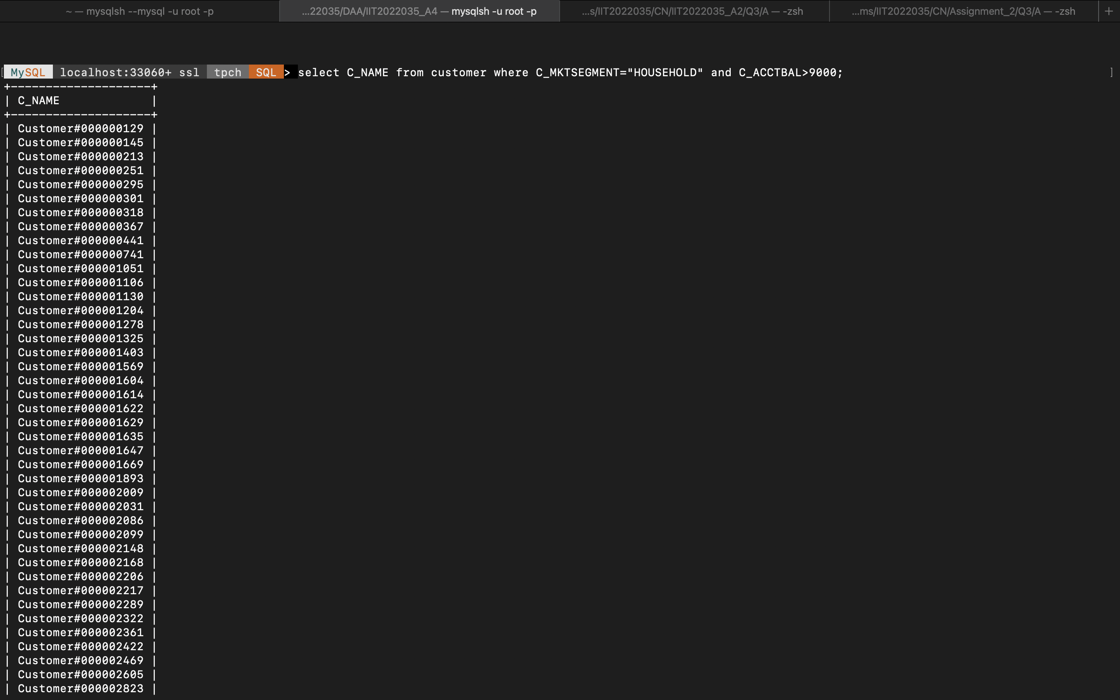uery:**

**select C_NAME from customer where C_MKTSEGMENT="HOUSEHOLD" and C_ACCTBAL>9000;**

**Q2.Query:** select distinct P_PARTKEY, P_NAME from region as r, nation as n, supplier as s, part as p,

partsupp as ps where n.N_NATIONKEY=r.R_REGIONKEY and s. S_NATIONKEY=n.N_NATIONKEY and ps.PS_SUPPKEY=s. S_SUPPKEY and ps.PS_PARTKEY=p

P_PARTKEY order by P_PARTKEY;

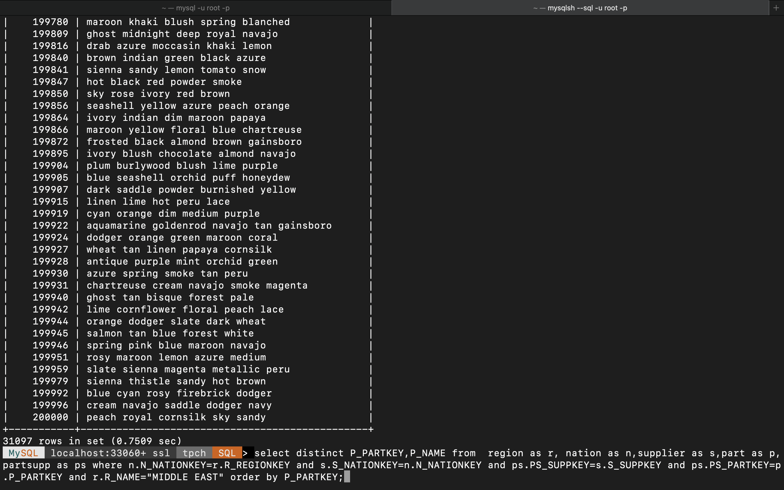

**Q3. Query:**

select count(distinct P_PARTKEY) from

region as r, nation as n, supplier as s, part as p,

partsupp as ps where n.N_NATIONKEY=r.R

_REGIONKEY and

s.S_NATIONKEY=n.N_NATIONKEY and ps.PS_SUPPKEY=s.S_SUPPKEY and ps.PS_PARTKEY=p

•P_PARTKEY and r.R_NAME="EUROPE" order by P_PARTKEY;

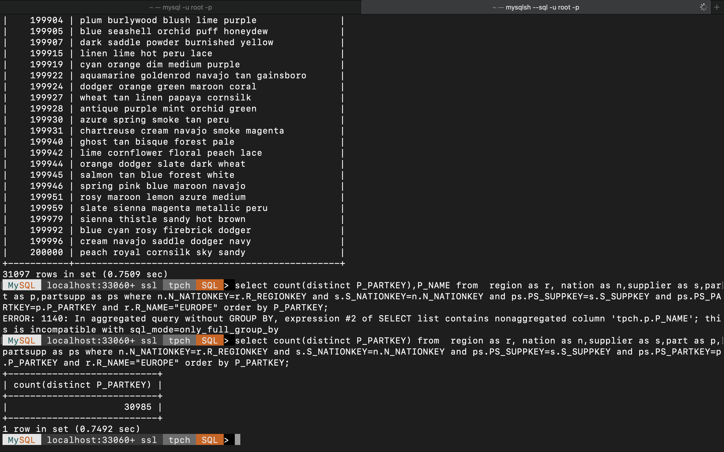

**Q4. Query:**

select distinct P_NAME from region as r, nation as n, supplier as s, part as p, partsupp as

ps where n.N_NATIONKEY=r.R_REGIONKEY and s.S_NATIONKEY=n.N_NATIONKEY and ps.PS_SUPPKEY=s. S_SUPPKEY and ps.PS_PARTKEY=p. P_PARTKEY and r.R_NAME<>"EUROPE" ;_

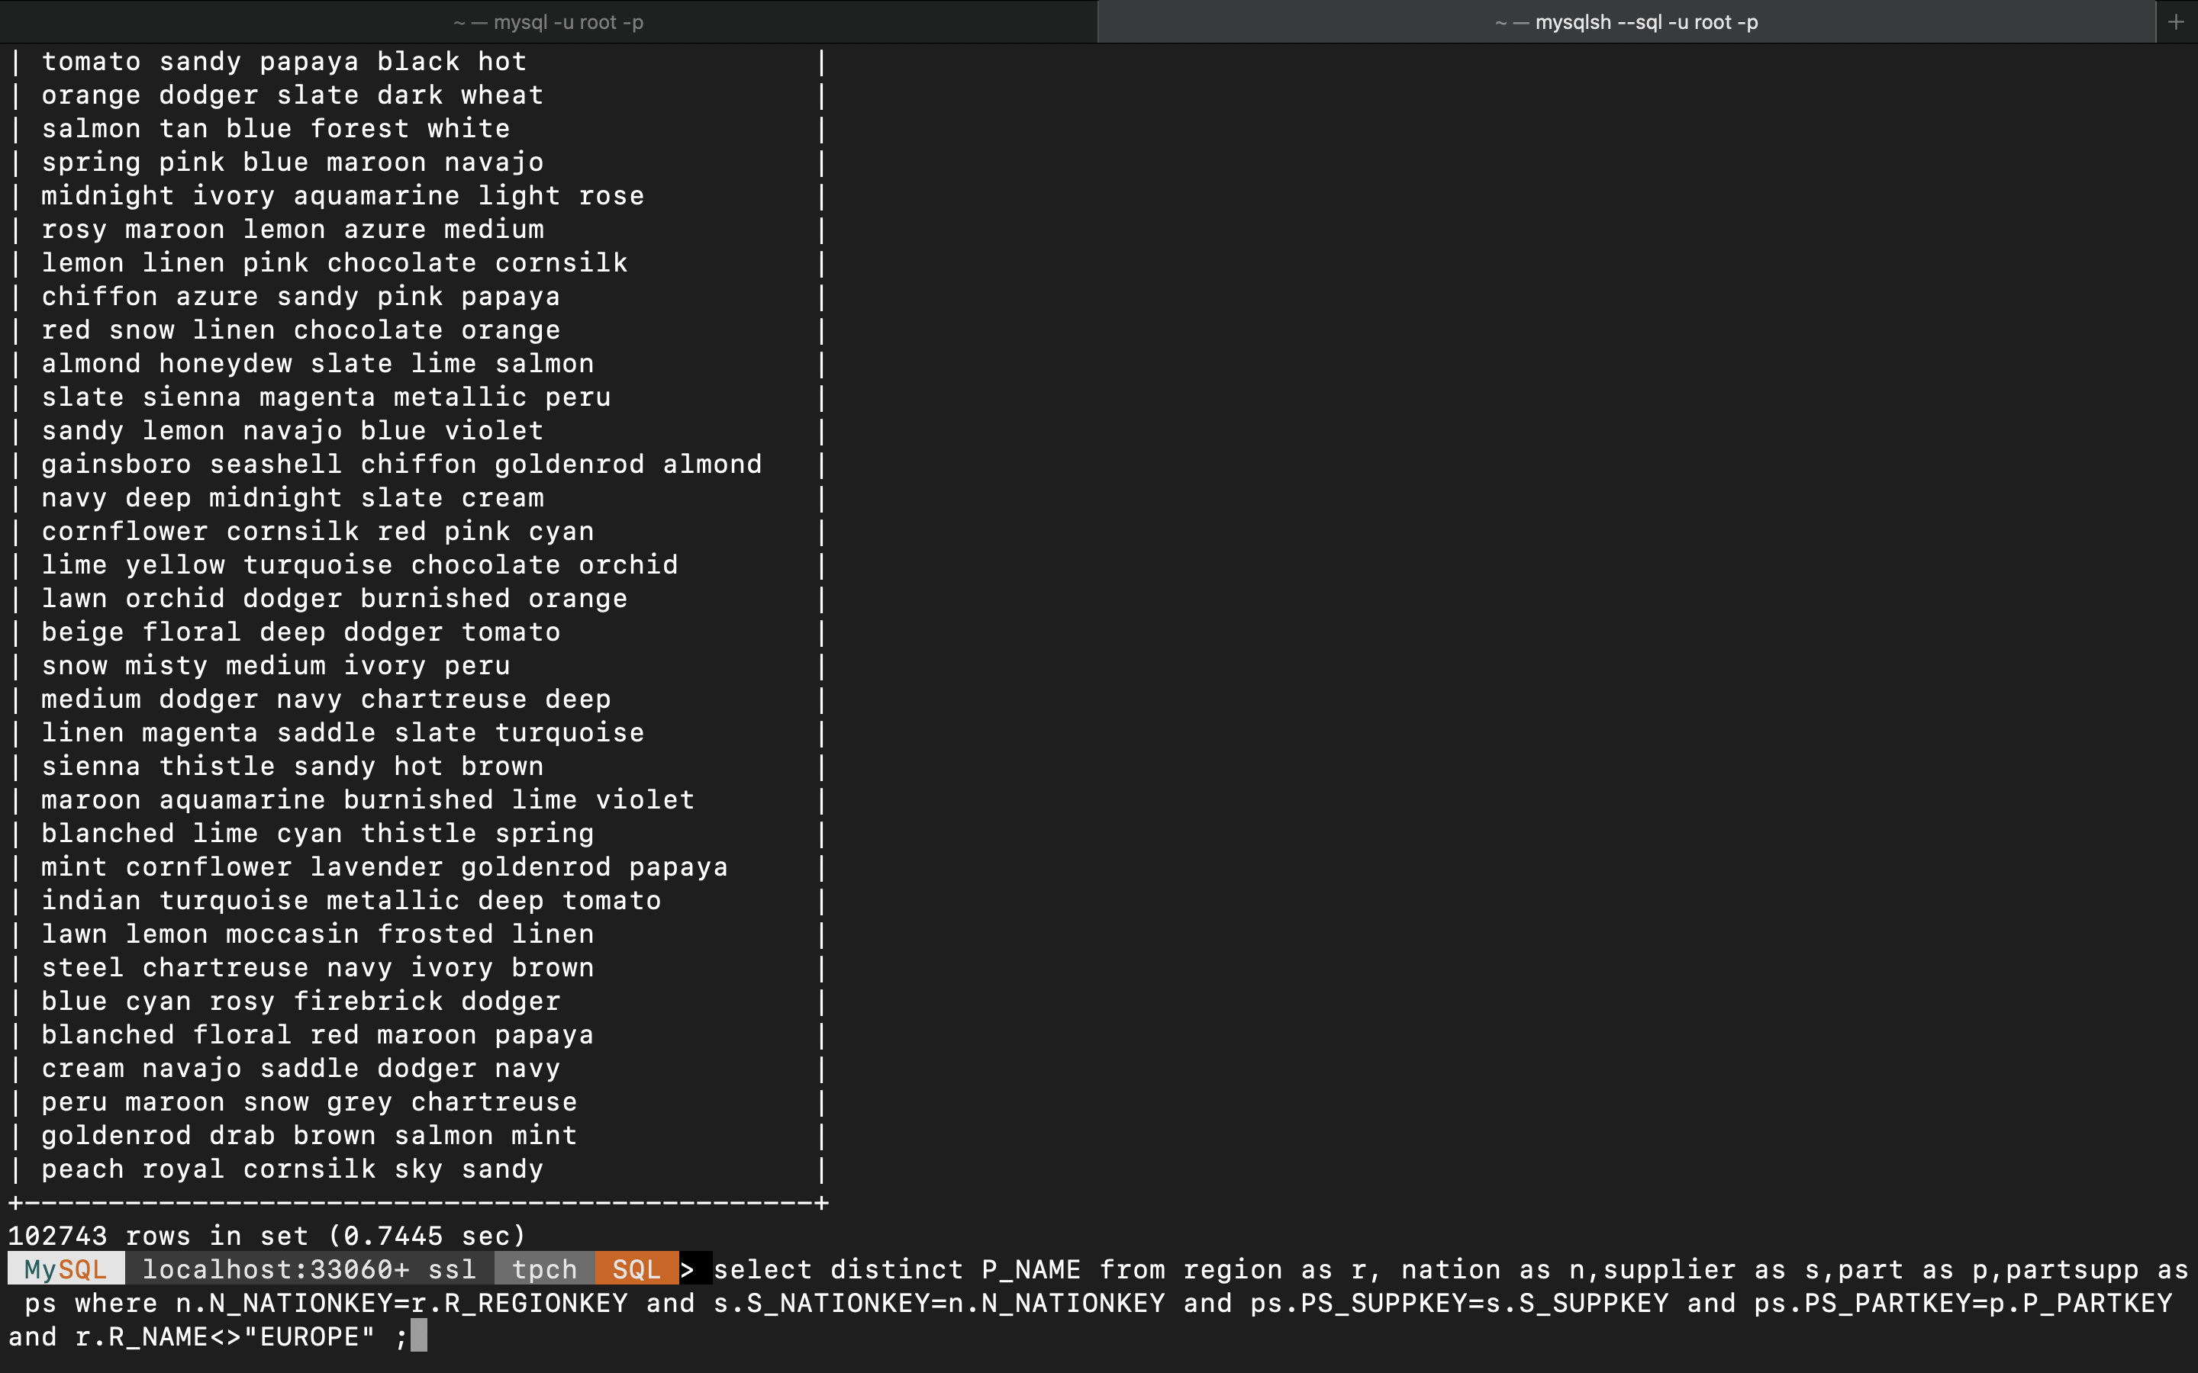

**Q5. Query:**

SELECT DISTINCT

c.C_NAME AS customer_name,

c.C_PHONE AS customer_phone,

r.R_NAME AS customer_region

FROM

customer AS c

JOIN

nation AS n1 ON c.C_NATIONKEY = n1.N_NATIONKEY

JOIN

region AS r ON r.R_REGIONKEY = n1.N_NATIONKEY

JOIN

orders AS o ON c.C_CUSTKEY = o.O_CUSTKEY

JOIN

lineitem AS l ON o.O_ORDERKEY = l.L_ORDERKEY

JOIN

partsupp AS ps ON l.L_PARTKEY = ps.PS_PARTKEY AND l.L_SUPPKEY = ps.PS_SUPPKEY

JOIN

supplier AS s ON ps.PS_SUPPKEY = s.S_SUPPKEY

JOIN

nation AS n2 ON s.S_NATIONKEY = n2.N_NATIONKEY

WHERE

NOT EXISTS (

SELECT 1

FROM

partsupp AS ps2

JOIN

supplier AS s2 ON ps2.PS_SUPPKEY = s2.S_SUPPKEY

JOIN

nation AS n3 ON s2.S_NATIONKEY = n3.N_NATIONKEY

WHERE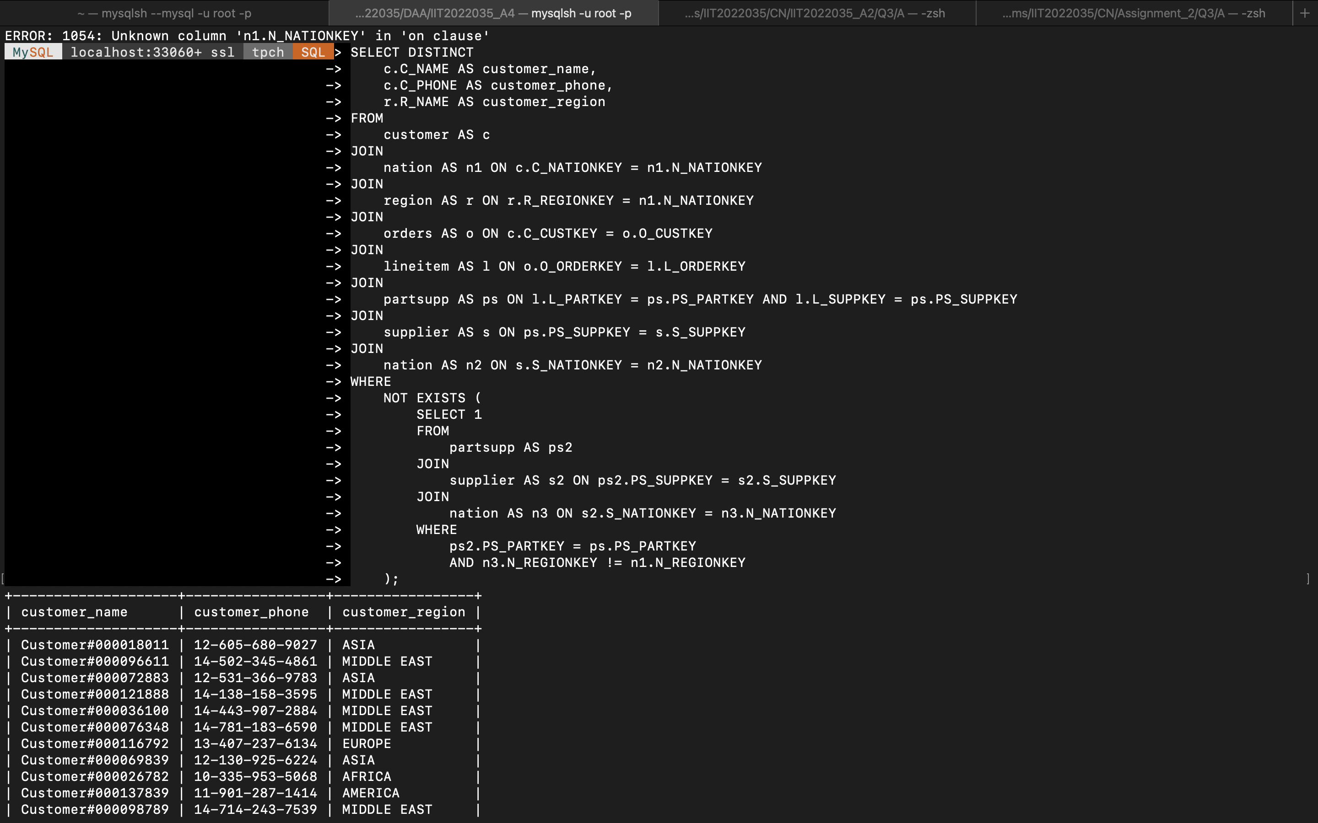

ps2.PS_PARTKEY = ps.PS_PARTKEY

AND n3.N_REGIONKEY != n1.N_REGIONKEY

);

**Q6. Query:**

SELECT MAX(L_EXTENDEDPRICE) AS highest_ extended

-> FROM lineitem

→ WHERE L DISCOUNT > L_TAX;

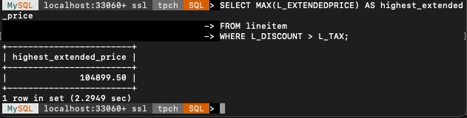

**Q7. Query:**

**WITH OrderLineitemDiff AS (**

**SELECT**

**0. 0_ORDERKEY,**

**DATEDIFF (MIN(1.L_SHIPDATE), MAX (1.L_COMMITDATE)) AS max_diff**

**FROM**

**orders o**

**JOIN**

**lineitem 1 ON o. 0_ORDERKEY = 1. L_ORDERKEY**

**GROUP BY**

**o.O_ORDERKEY**

**)**

**SELECT**

**COUNT (O_ORDERKEY) AS num_orders**

**FROM**

**OrderLineitemDiff**

**WHERE**

**max_diff <= 14;**

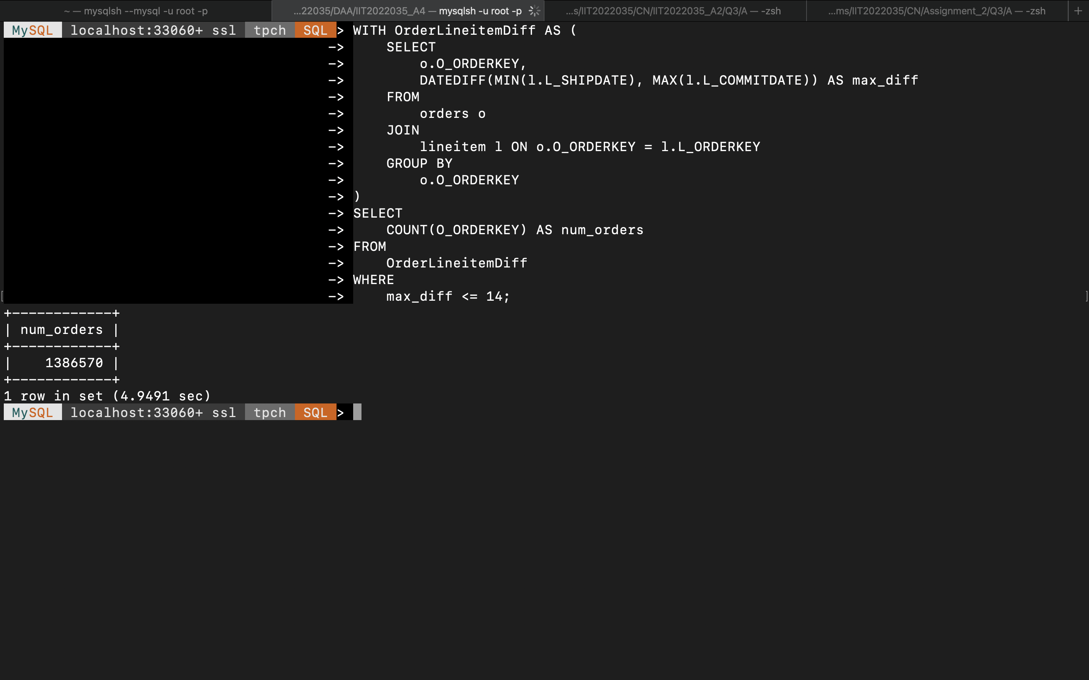

**Q8. Query:**

SELECT COUNT(DISTINCT C_CUSTKEY) AS num_custome!

rs_without_american_parts FROM customer AS e WHERE C.C_CUSTKEY IN (

SELECT DISTINCT

-O_CUSTKEY

FROM orders AS o

JOIN lineitem AS L ON 0.0_ORDERKEY = 1. L_ORDERKEY

JOIN partsupp AS ps ON 1.L_ PARTKEY = ps.PS_PARTKEY AND 1.L_SUPPKEY = ps.PS_SUPPKEY

OIN supplier AS s ON ps. PS_SUPPKEY = S. S_ SUPPKEY

JOIN nation AS n ON n-N_NATIONKEY =

S. S_NATIONKEY

WHERE n.N_NAME <>

"UNITED STATES');

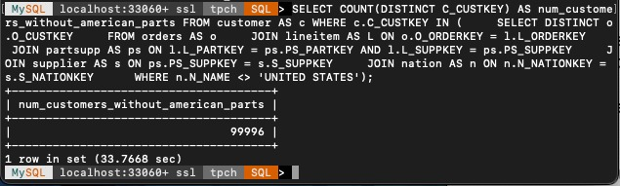

**Q9. Query:**

SELECT _NAME FROM nation as n,

custom

as

FROM

WHERE c.C_NATIONKEY=n.N_NATIONKEY AND c. C_ACCTBAL=(SELECT max (C_ACCTBAL) customer);

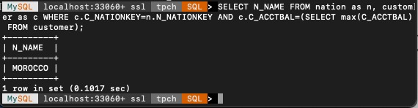

**Q10. Query:**

SELECT DISTINCT

n. N_NAME AS country_name FROM

nation AS n JOIN

customer AS c

ON n. N_NATIONKEY = c. C_NATIONKEY JOIN

Orders AS o ON c. C_CUSTKEY = 0. 0_CUSTKEY JOIN

lineitem AS L ON 0.0_ORDERKEY = 1. L_0

RDERKEY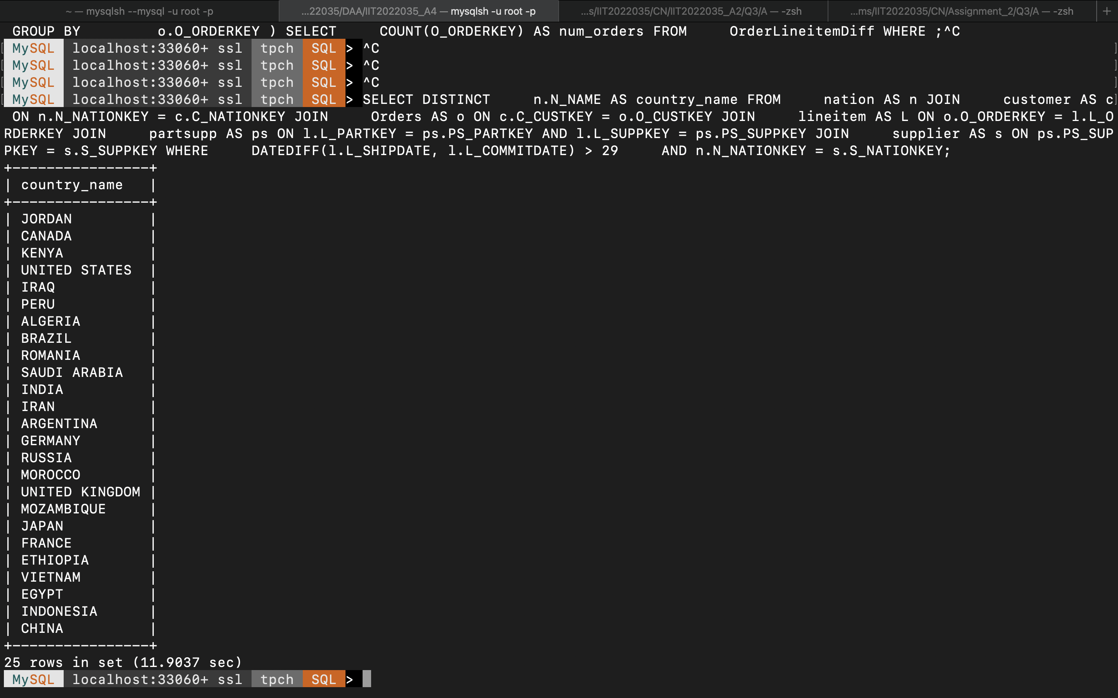 JOIN

partsupp AS ps ON 1.L_PARTKEY = ps.PS_PARTKEY AND 1.L_SUPPKEY = ps.PS_SUPPKEY JOIN

supplier AS s ON ps. PS_SUP

PKEY = S.S_SUPPKEY WHERE

DATEDIFF (1.L_SHIPDATE, 1.L_COMMITDATE) > 29

AND n.N_NATIONKEY = s. S_NATIONKEY;